A full Binary tree is a special type of binary tree in which every parent node/internal node has either two or no children.
It is also known as a proper binary tree.
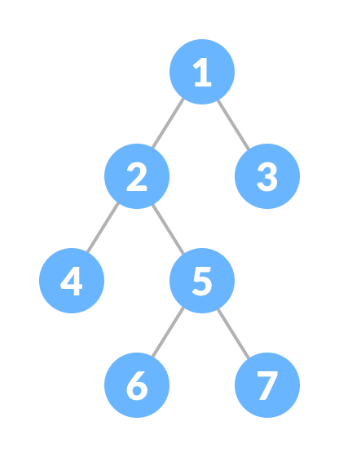Full Binary Tree

Full Binary Tree Theorems
Let, i = the number of internal nodes
n = be the total number of nodes
l = number of leaves
λ = number of levels
- The number of leaves is i + 1.
- The total number of nodes is 2i + 1.
- The number of internal nodes is (n – 1) / 2.
- The number of leaves is (n + 1) / 2.
- The total number of nodes is 2l – 1.
- The number of internal nodes is l – 1.
- The number of leaves is at most 2^{λ - 1}.
// Checking if a binary tree is a full binary tree in Java

class Node {
int data;
Node leftChild, rightChild;

Node(int item) {
data = item;
leftChild = rightChild = null;
}
}

class BinaryTree {
Node root;

// Check for Full Binary Tree
boolean isFullBinaryTree(Node node) {

// Checking tree emptiness
if (node == null)
return true;

// Checking the children
if (node.leftChild == null && node.rightChild == null)
return true;

if ((node.leftChild != null) && (node.rightChild != null))
return (isFullBinaryTree(node.leftChild) && isFullBinaryTree(node.rightChild));

return false;
}

public static void main(String args[]) {
BinaryTree tree = new BinaryTree();
tree.root = new Node(1);
tree.root.leftChild = new Node(2);
tree.root.rightChild = new Node(3);
tree.root.leftChild.leftChild = new Node(4);
tree.root.leftChild.rightChild = new Node(5);
tree.root.rightChild.leftChild = new Node(6);
tree.root.rightChild.rightChild = new Node(7);

if (tree.isFullBinaryTree(tree.root))
System.out.print("The tree is a full binary tree");
else
System.out.print("The tree is not a full binary tree");
}
}

